Test Reports

🔹 Definition
# Source: Chatgpt (GPT-5-Standard) at [8/18/2025]
A Test Report is a formal document that summarizes the testing activities, results, progress, and quality status of a software project.
It provides evidence of testing work done, highlights defects and risks, and communicates the readiness of the product for release.
👉 In simple terms:
It’s the tester’s way of telling stakeholders what was tested, what was found, and whether the software is ready.

🛠️ Types of Test Reports
# Source: Chatgpt (GPT-5-Standard) at [8/18/2025]
- Daily/Status Test Report
  - Shared during testing execution.
  - Shows progress: tests executed, passed, failed, blocked, defects found.
  - Example: “Today 50 test cases executed, 40 passed, 8 failed, 2 blocked.”
- Test Summary Report (TSR)
  - Created at the end of a test phase (e.g., system testing, UAT).
  - Summarizes overall testing results, defect density, coverage, risks, and recommendations.
  - Example: “95% test cases passed, major defects fixed, product ready for release.”
- Defect Report
  - Details about specific defects found.
  - Includes severity, priority, steps to reproduce, status.

📌 Key Contents of a Test Report
# Source: Chatgpt (GPT-5-Standard) at [8/18/2025]
A good test report usually includes:
- Test Objectives – Why testing was done.
- Scope of Testing – Features/modules tested and not tested.
- Test Environment – Hardware, software, tools used.
- Test Coverage – % of requirements or code tested.
- Test Execution Summary – No. of test cases passed, failed, blocked, skipped.
- Defect Summary – Defects found, open vs closed, severity distribution.
- Risks & Issues – Unresolved defects or potential release risks.
- Effort & Cost Spent – Time taken vs planned, resource utilization.
- Exit Criteria Status – Whether defined exit criteria were met.
- Recommendations – Is the product ready for release or more testing needed?

📊 Example Test Execution Report (Web App Project)
# Source: Chatgpt (GPT-5-Standard) at [8/18/2025]
- Test Cases Designed: 500
- Executed: 480
  - Passed: 430
  - Failed: 40
  - Blocked: 10
- Defects Found: 55
  - Critical: 5 (2 open, 3 fixed)
  - Major: 20 (5 open, 15 fixed)
  - Minor: 30 (10 open, 20 fixed)
- Test Coverage: 92% requirements tested
- Exit Criteria: 95% pass rate → Achieved
- Recommendation: Ready for release with low-risk defects deferred.

✅ Why Test Reports Are Important
# Source: Chatgpt (GPT-5-Standard) at [8/18/2025]
✔ Provide transparency to stakeholders.
✔ Help in release decisions (go/no-go).
✔ Serve as evidence of quality and compliance.
✔ Support process improvement by analyzing test effectiveness.
✔ Help track defect trends and risks across cycles.

Test Reports – Purpose, Content & Audience

🎯 1. Purpose of Test Reports
# Source: Chatgpt (GPT-5-Standard) at [8/18/2025]
Test reports are created to communicate the testing status, results, progress, and quality of the product to stakeholders.
Main purposes:
- Show what has been tested and what is pending.
- Provide visibility into defects, risks, and quality.
- Support decision-making (e.g., release readiness).
- Track progress against the test plan.
- Document testing efforts for future reference and audits.
👉 In short: Test reports answer “Where are we in testing, what have we found, and are we ready to release?”

📦 2. Content of Test Reports
# Source: Chatgpt (GPT-5-Standard) at [8/18/2025]
The exact content may vary by type (Daily Status, Test Summary, Defect Report), but generally includes:
- Project / Release Details – Name, version, build, environment.
- Testing Scope – What features/modules were covered.
- Test Progress – Number of test cases executed, passed, failed, blocked.
- Defect Metrics – Open, closed, severity, priority.
- Test Coverage – % of requirements or features tested.
- Risks & Issues – Risks identified and mitigation status.
- Entry/Exit Criteria Status – Whether testing is aligned with completion criteria.
- Quality Assessment – Overall quality perception of the product.
- Recommendations – Release readiness or further testing needed.
- Conclusion – Final remarks (e.g., Product stable but critical bug open).

👥 3. Audience for Test Reports
# Source: Chatgpt (GPT-5-Standard) at [8/18/2025]
Different stakeholders use test reports for different purposes:
- Test Manager / QA Lead
  - Monitor testing progress, resource usage, and strategy alignment.
- Project Manager / Release Manager
  - Decide on release readiness, timelines, and risk management.
- Developers
  - Get details on defects, reproduce issues, and track fixes.
- Business Analysts / Product Owners
  - Ensure requirements are covered and risks are reduced.
- Senior Management / Clients
  - Understand overall product quality, business risk, and delivery confidence.

✅ Summary Table
# Source: Chatgpt (GPT-5-Standard) at [8/18/2025]
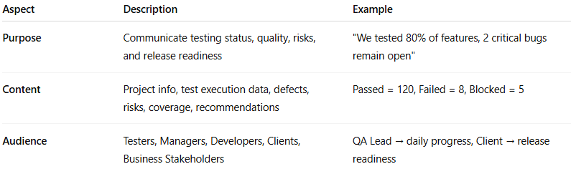
Aspect | Description | Example
Purpose | Communicate testing status, quality, risks, and release readiness | "We tested 80% of features, 2 critical bugs remain open"
Content | Project info, test execution data, defects, risks, coverage, recommendations | Passed = 120, Failed = 8, Blocked = 5
Audience | Testers, Managers, Developers, Clients, Business Stakeholders | QA Lead → daily progress, Client → release readiness

👉 In short:
Test Reports act as a communication bridge between testers and stakeholders, showing the true quality status of the software product.

